**JMETER**

**url:** https://www.bunnycart.com/

1. Created a test plan-Bunnycart Casestudy Test Plan

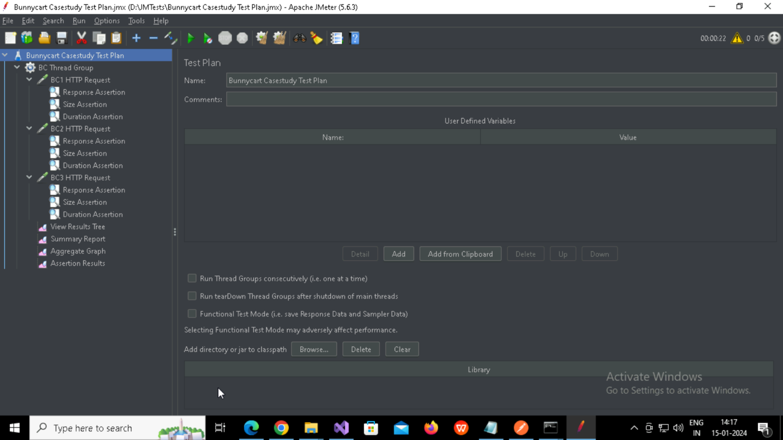

* 1. Created Thread group-BC Thread Group

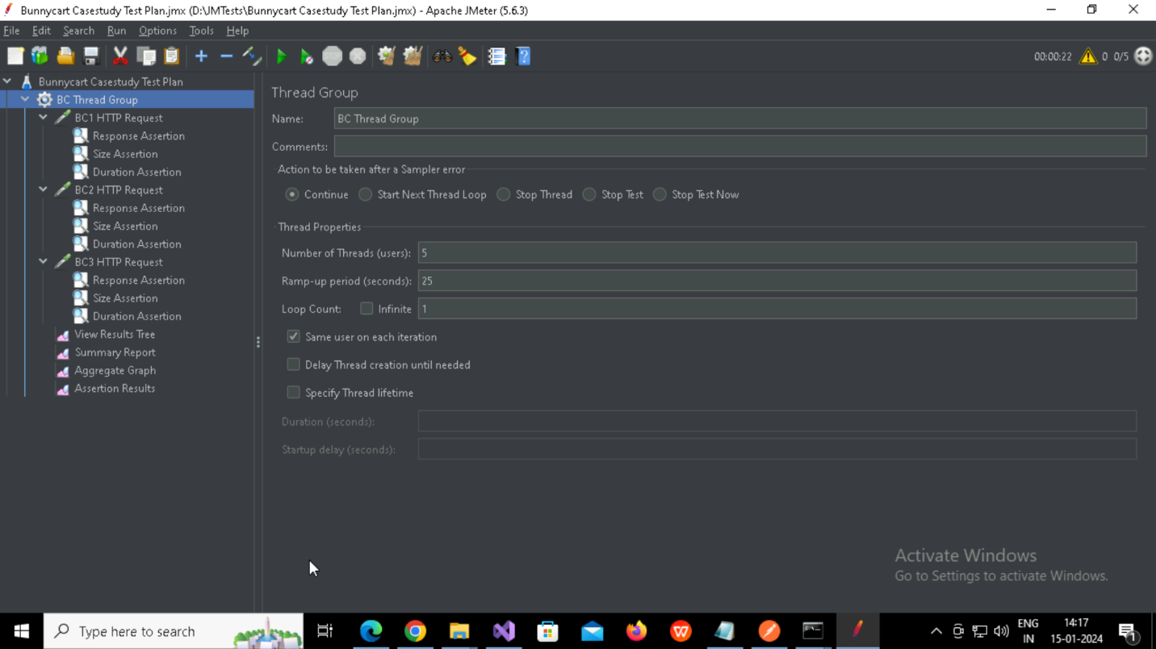

* + 1. Created HTTP Sampler Request-BC1 HTTP Request

**Path**: www.bunnycart.com

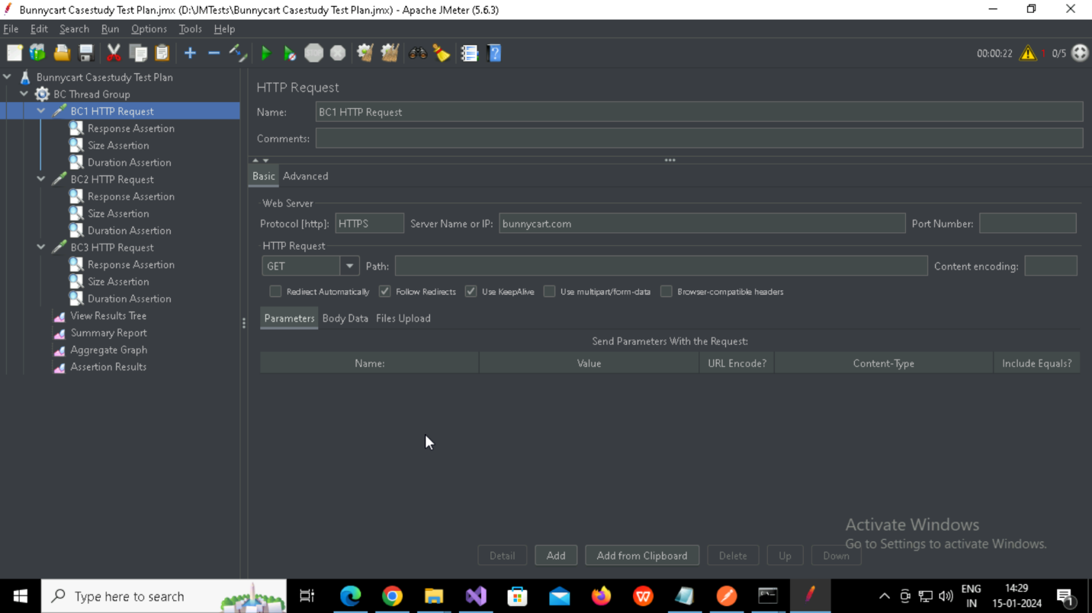

* + - 1. Created Response Assertion

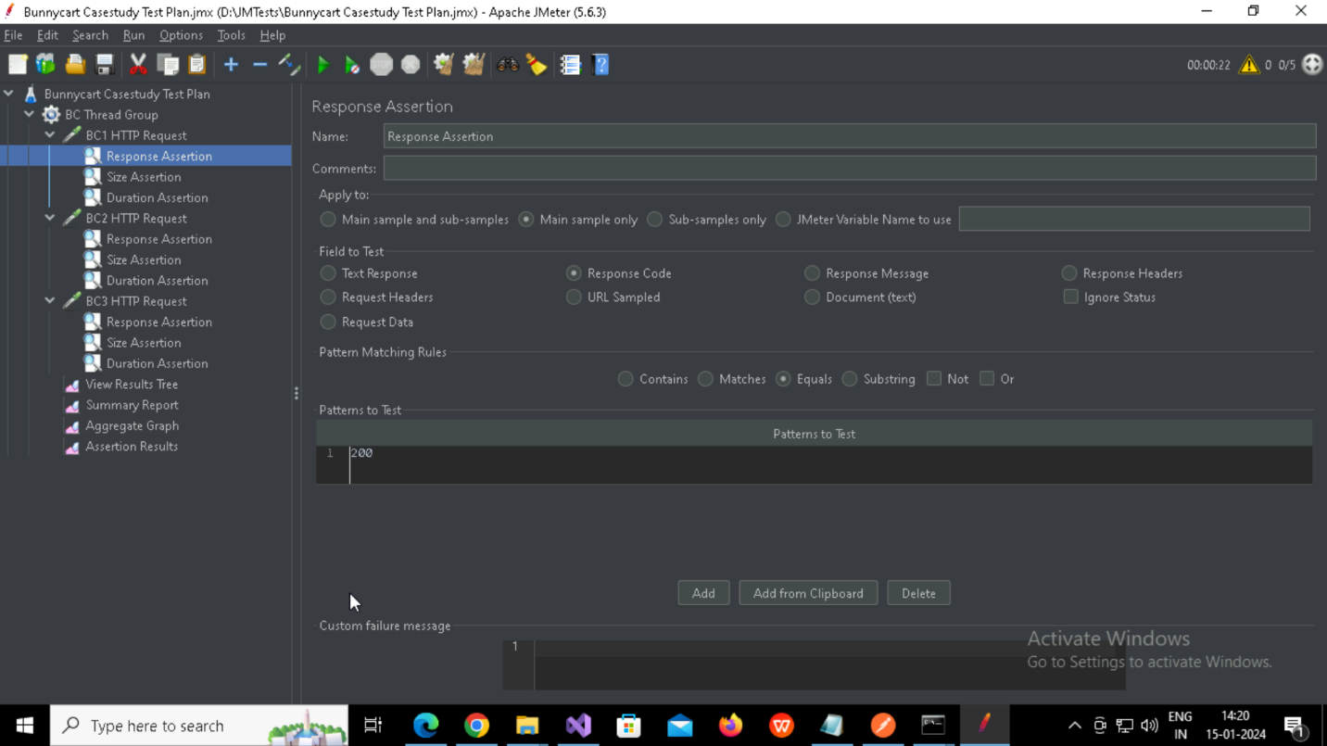

* + - 1. Created Size Assertion

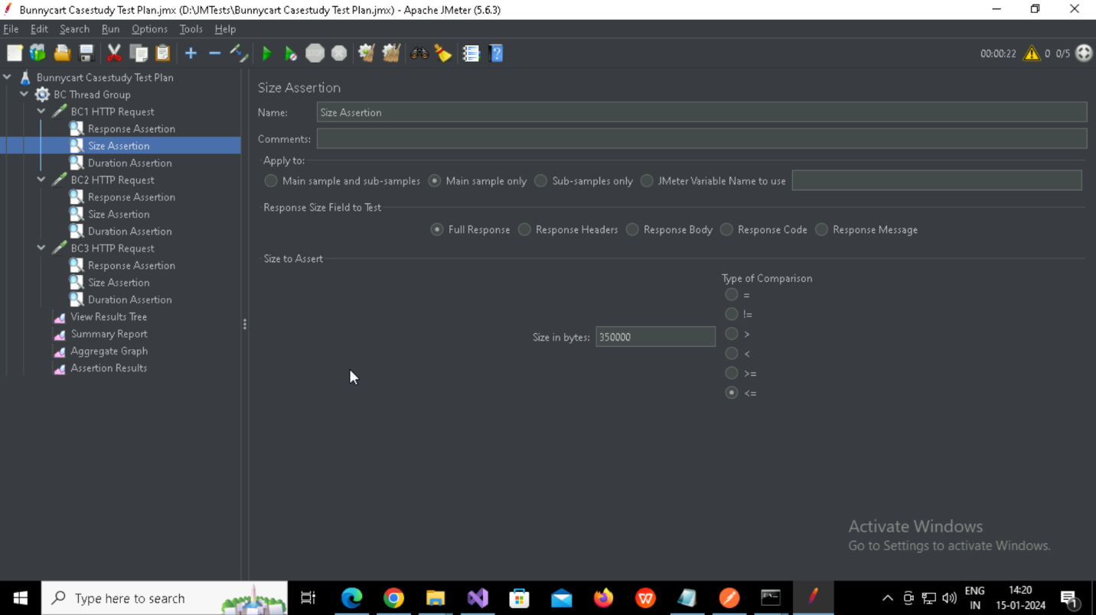

* + - 1. Created Duration Assertion

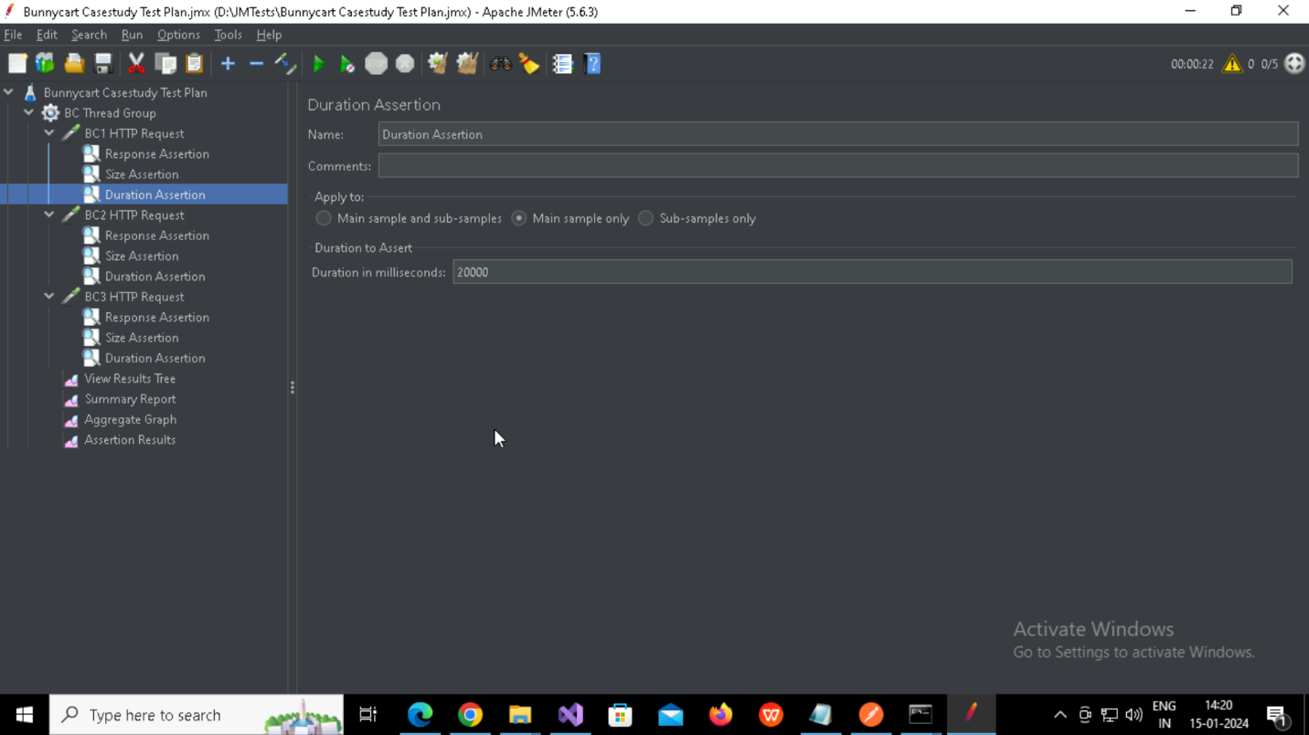

* + 1. Created HTTP Sampler Request-BC2 HTTP Request

**Path**: /aquarium-plants

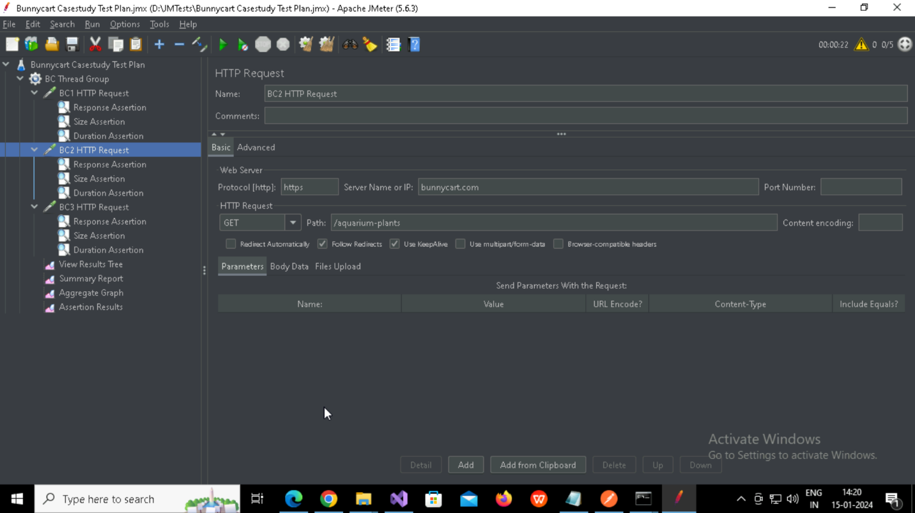

* + - 1. Created Response Assertion

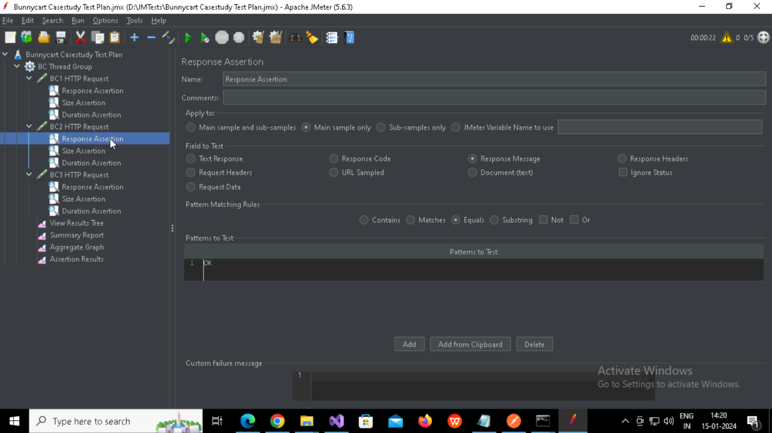

* + - 1. Created Size Assertion

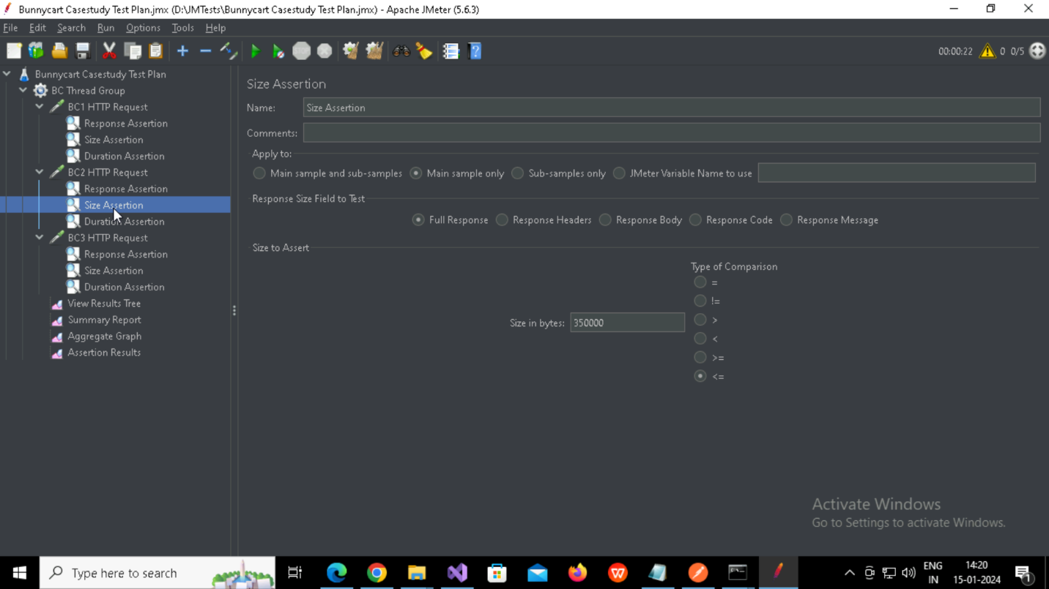

* + - 1. Created Duration Assertion

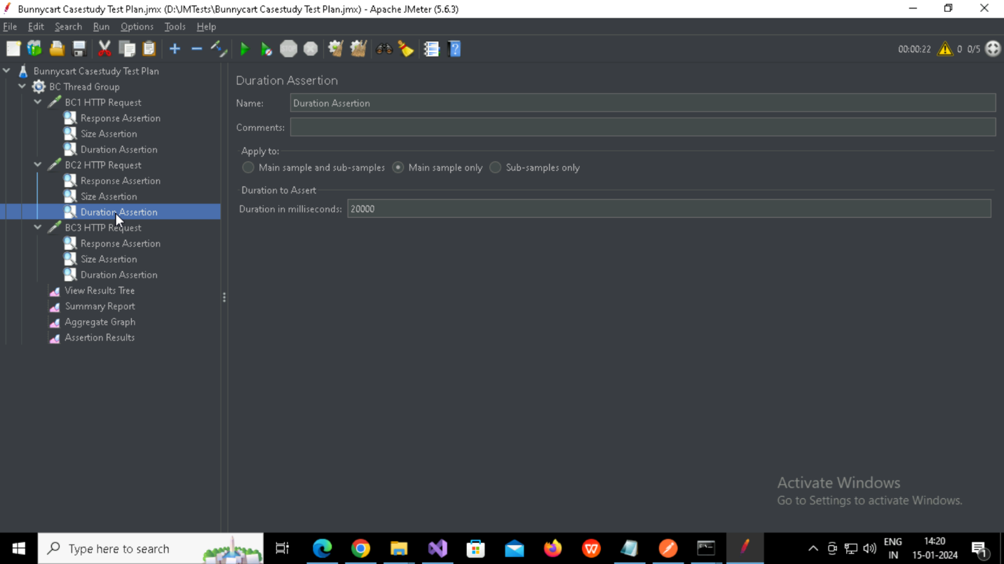

* + 1. Created HTTP Sampler Request-BC3 HTTP Request

**Path**: /marsilea-hirsuta

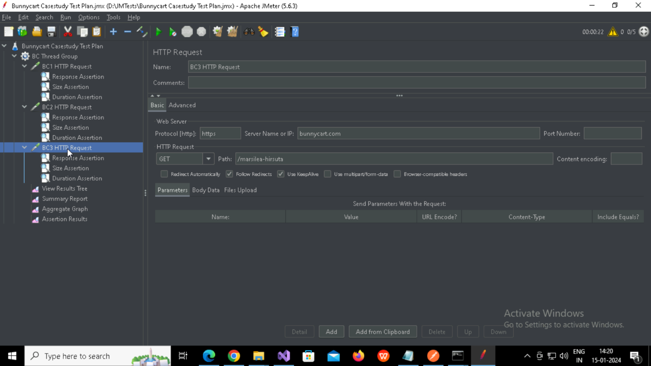

1.1.3.1 Created Response Assertion

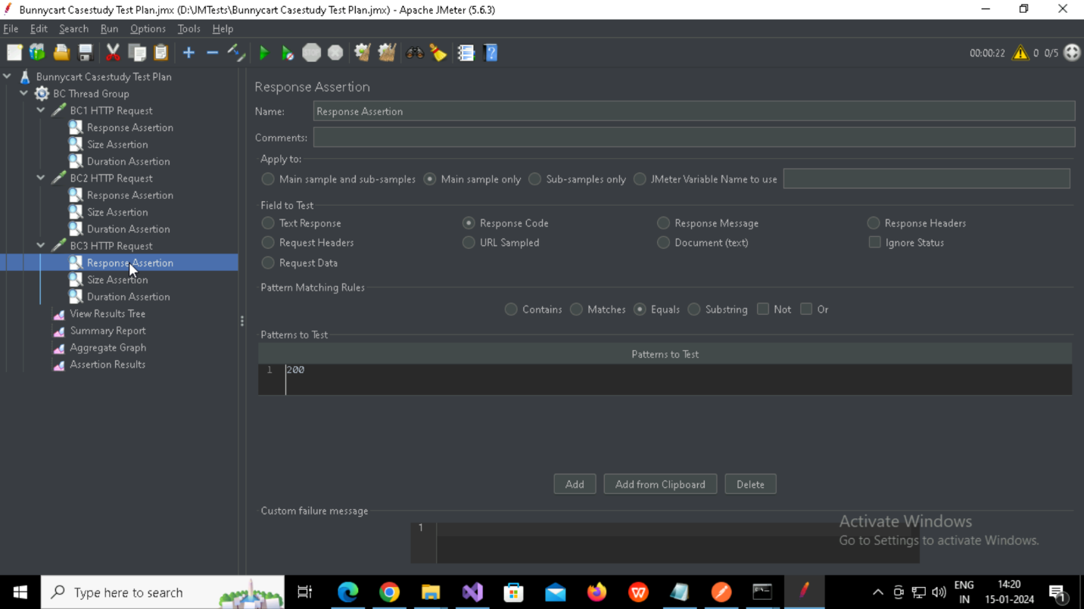

1.1.3.2 Created Size Assertion

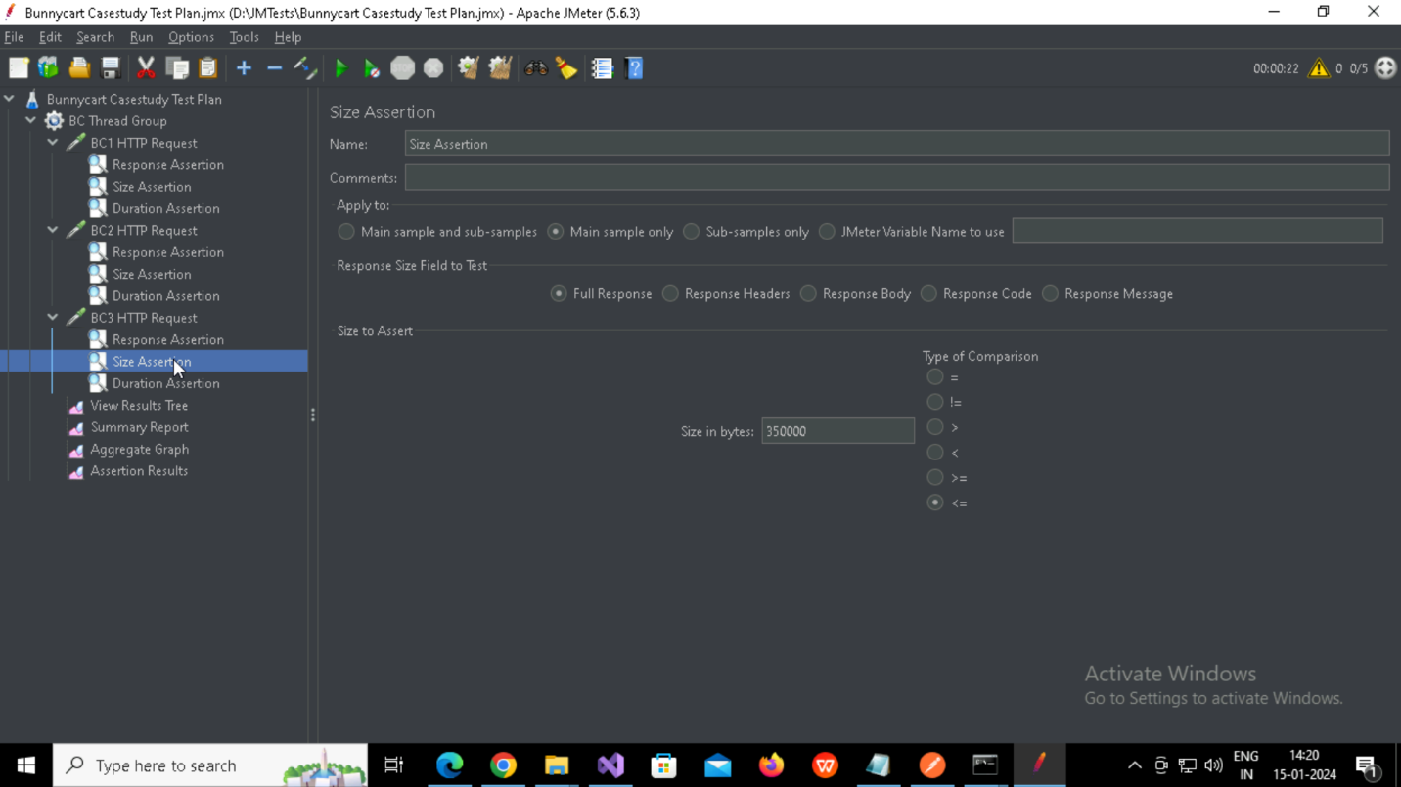

1.1.3.3 Created Duration Assertion

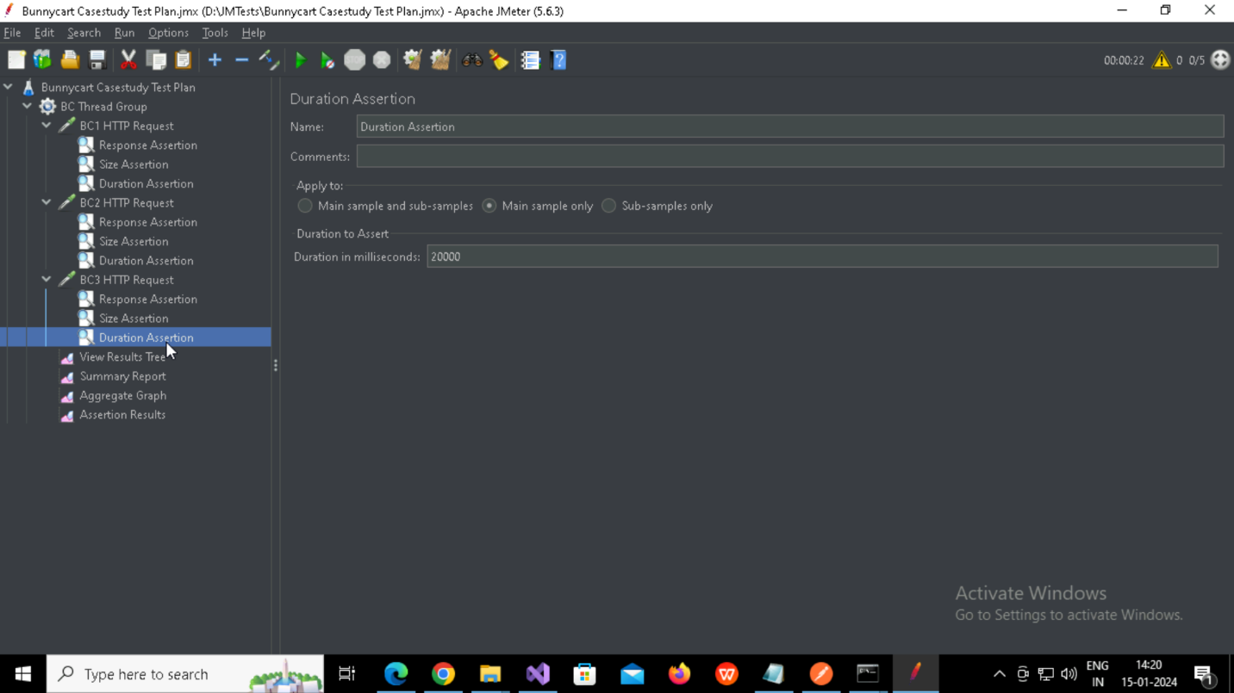

* + 1. Creating Listeners

(1)View Results Test

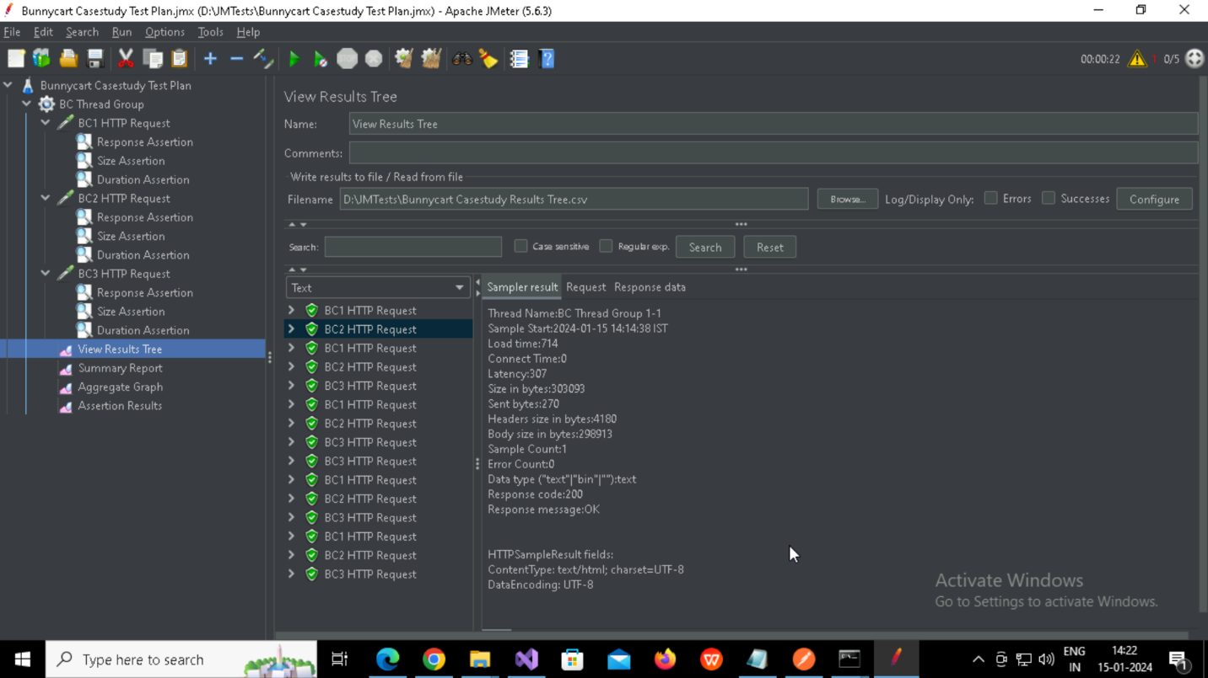

(2)Summary Report

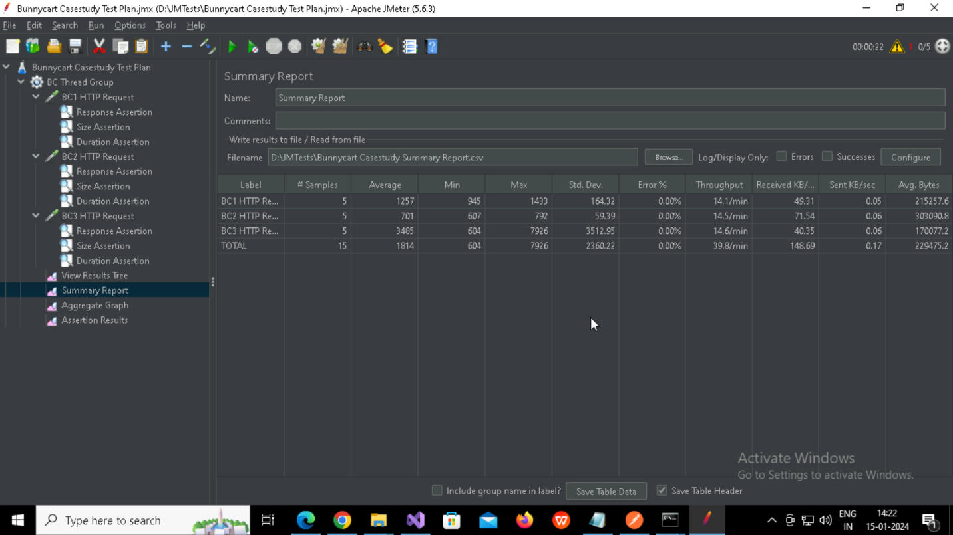

(3)Aggregate Grapgh

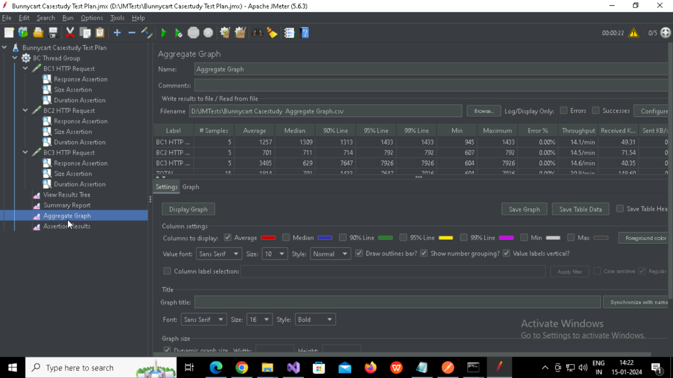

Graph:

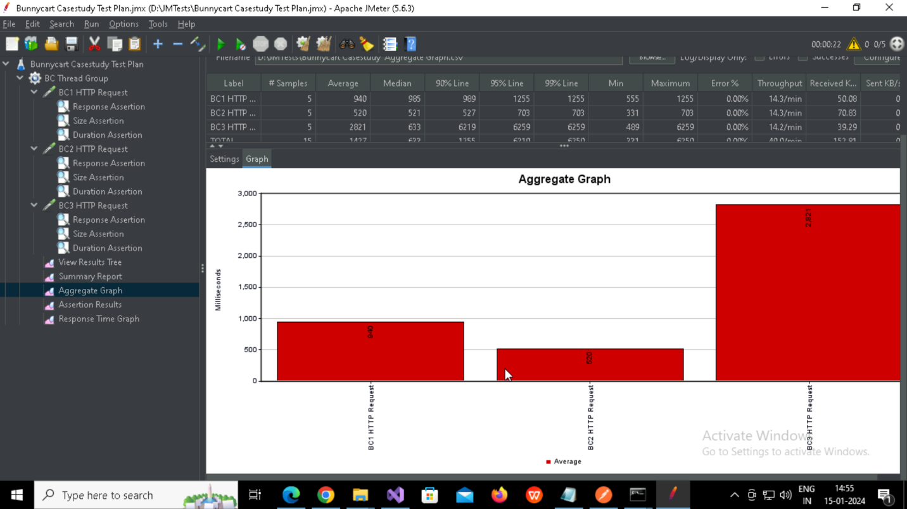

(4)Assertion Results

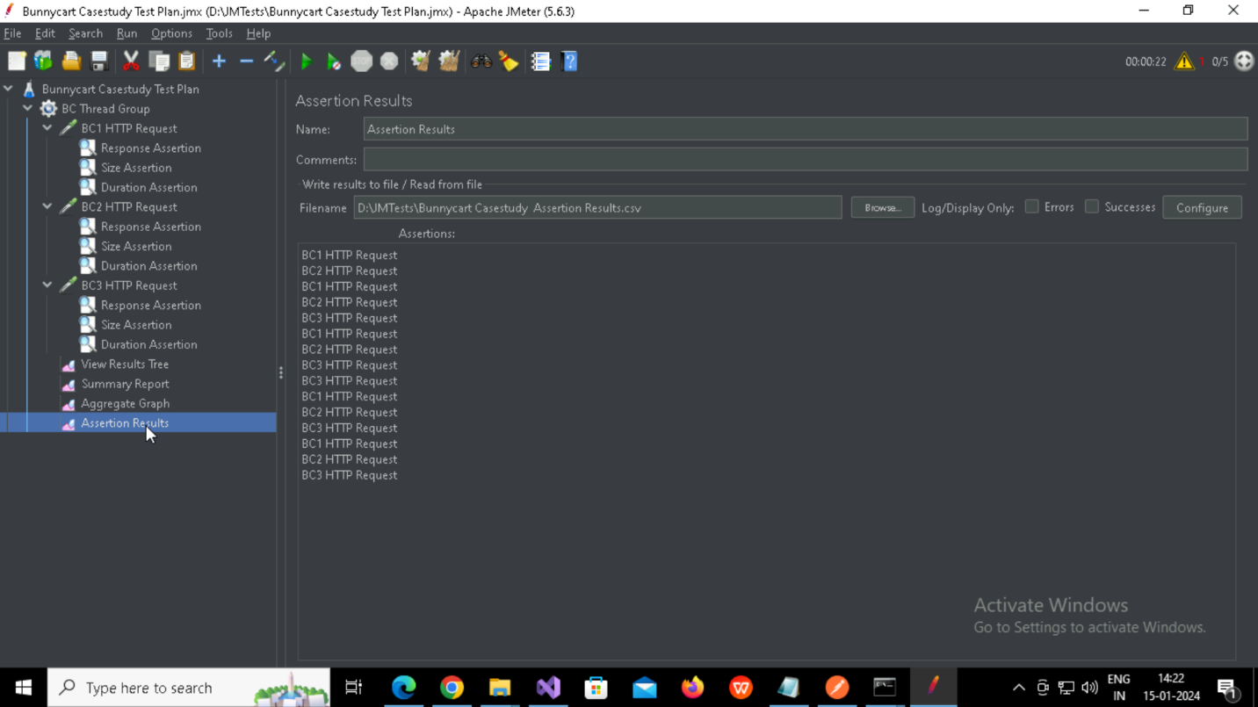

(5)Response Time Graph

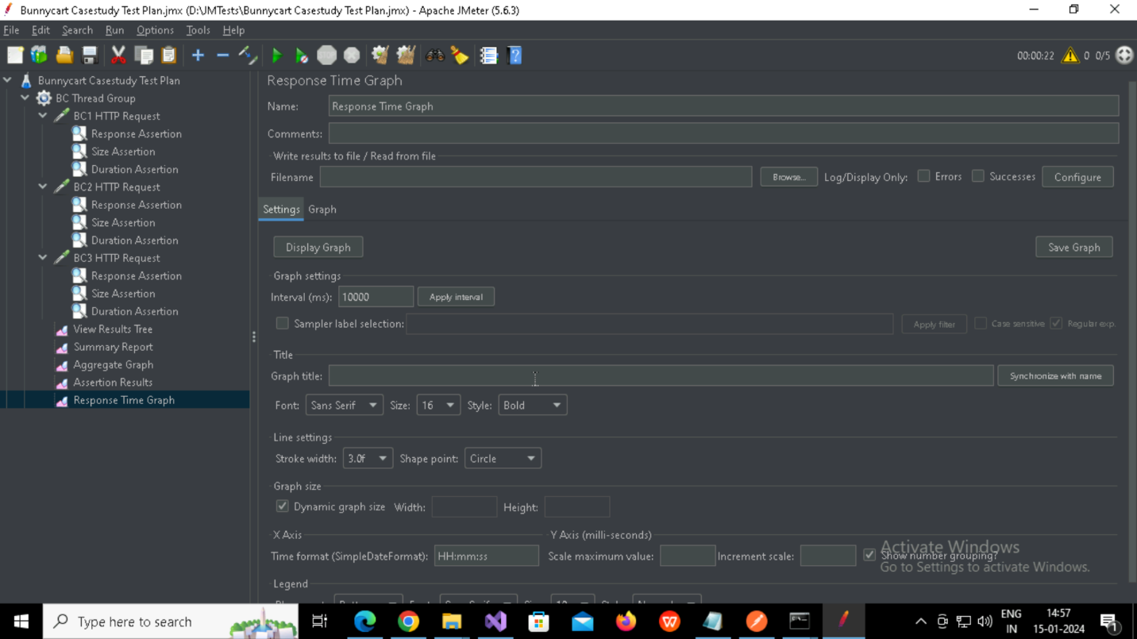

Graph:

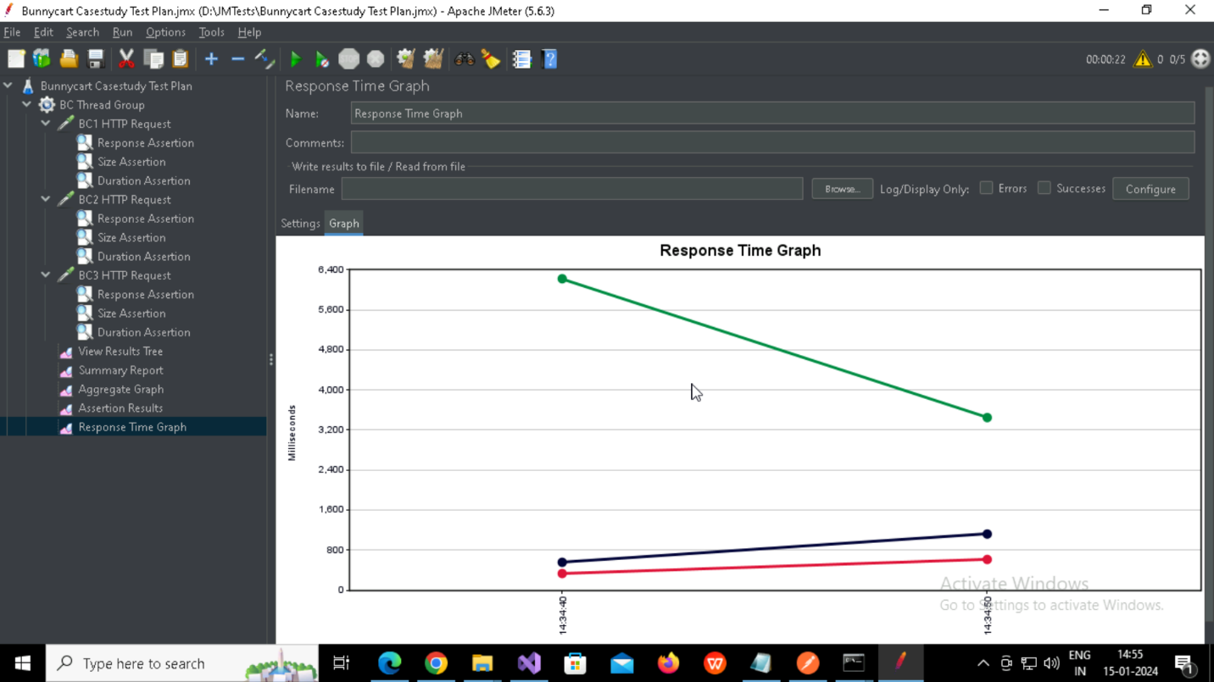

**Questions**

1. What is the average response time for the homepage of the website?

Ans)940

1. Did all requests meet the assertion criteria? If not, what failed?

Ans)Yes

1. How does the response time vary over time during the test run?

Ans)First two request gradually increases with time and the third request gradually decreases.